Health Care Data Drive Decision: Week 3 Project Submission pdf - STU649f97401a9bf1688180544

1. Total Patients:

Formula: Total Patient = COUNTROWS('Patient Details')

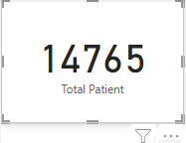

2)No of Males:

Formula: Males = CALCULATE(COUNTROWS('Patient Details'), 'Patient Details'[GENDER]="Male")

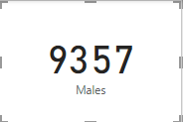

3)No of Females:

Formula: Females = CALCULATE(COUNTROWS('Patient Details'), 'Patient Details'[GENDER]="Female")

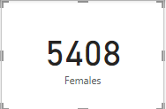

4) Male Patients Percentage:

Formula: Males Percentage = DIVIDE([Males],[Total Patient])

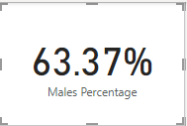

5) Female Patients Percentage:

Formula: Females Percentage = DIVIDE([Females],[Total Patient])

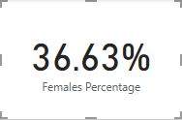

6)Decomposition tree of patients who have DM, BP, PULMONARY EMBOLISM and consume alcohol also.

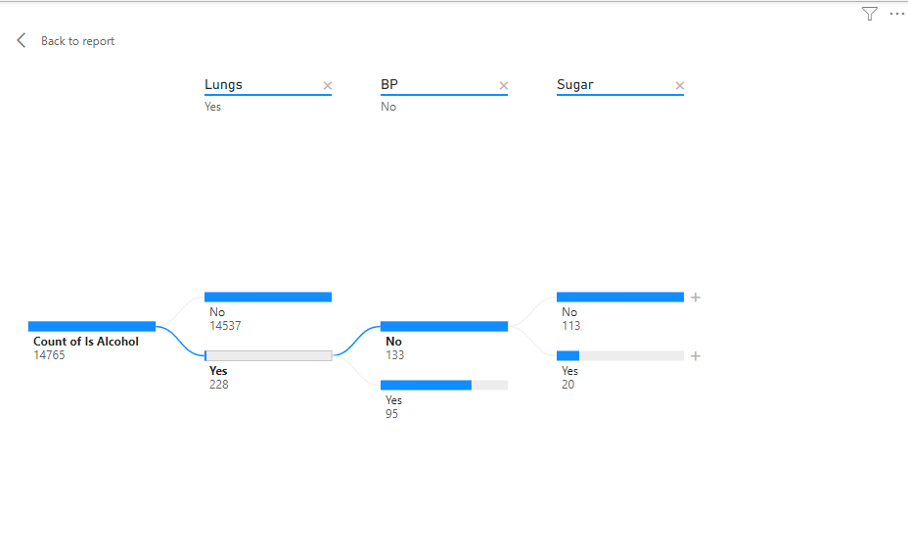

7) Decomposition tree of patients who have DM, NEURO, and consume alcohol by AGE GROUP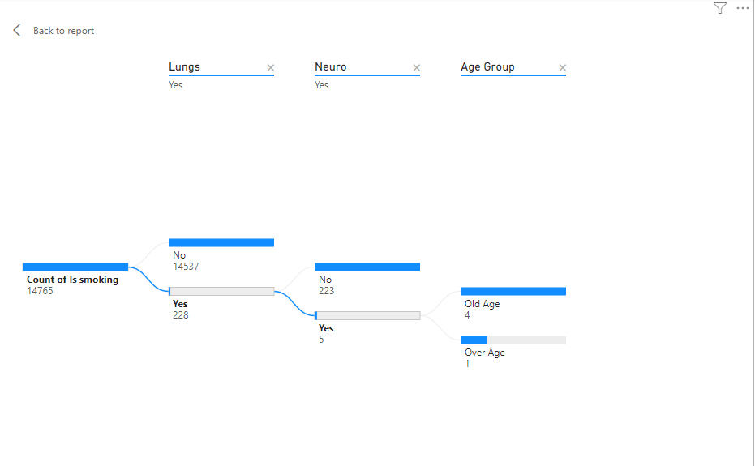

8)Bar chart on total patients by age group.

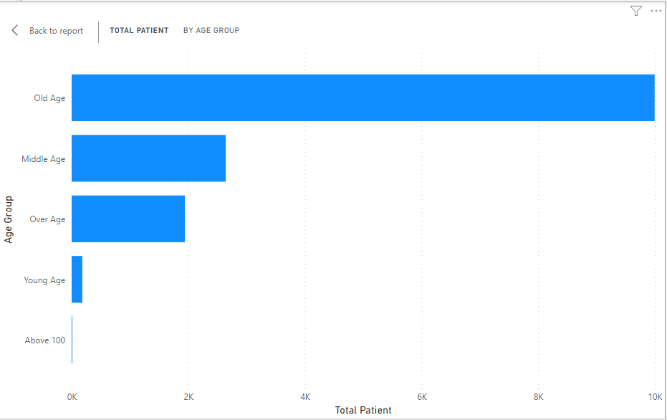

9)Line chart on total patients by every weekday.

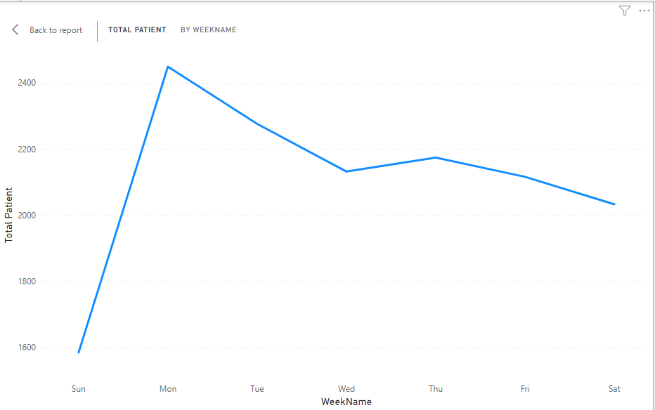

10) Average of Duration of Intensive unit stay:

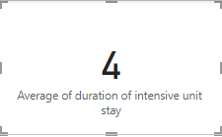

11) Average of Duration of Stay

